**------------------------------------------------------------**

**# 🍕 PIZZA SALES REPORT – SQL ANALYSIS**

**------------------------------------------------------------**

**-- View the dataset**

**SELECT * FROM pizza_sales;**

**------------------------------------------------------------**

**## ✅ KEY PERFORMANCE INDICATORS (KPIs)**

**------------------------------------------------------------**

**# 1️⃣ Total Revenue from Pizza Sales**

**SELECT SUM(total_price) AS total_revenue**

**FROM pizza_sales;**



**# 2️⃣ Average Order Value**

**SELECT SUM(total_price) / COUNT(DISTINCT order_id) AS avg_order_value**

**FROM pizza_sales;**



**# 3️⃣ Total Pizzas Sold**

**SELECT SUM(quantity) AS total_pizzas_sold**

**FROM pizza_sales;**



**# 4️⃣ Total Number of Pizza Orders**

**SELECT COUNT(DISTINCT order_id) AS total_orders**

**FROM pizza_sales;**



**# 5️⃣ Average Pizzas Per Order**

**SELECT**

**CAST(**

**CAST(SUM(quantity) AS DECIMAL(10,2)) /**

**CAST(COUNT(DISTINCT order_id) AS DECIMAL(10,2))**

**AS DECIMAL(10,2)**

**) AS avg_pizza_per_order**

**FROM pizza_sales;**



**------------------------------------------------------------**

**## 📊 SALES TRENDS & CHART ANALYSIS**

**------------------------------------------------------------**

**# 🔹 Daily Trend of Orders Over the Week**

**SELECT**

**DATENAME(WEEKDAY, order_date) AS order_day,**

**COUNT(DISTINCT order_id) AS total_orders**

**FROM pizza_sales**

**GROUP BY DATENAME(WEEKDAY, order_date),**

**DATEPART(WEEKDAY, order_date)**

**ORDER BY DATEPART(WEEKDAY, order_date);**

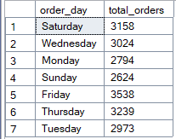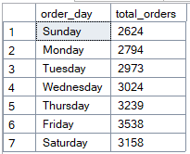

**# 🔹 Monthly Trend of Orders**

**SELECT**

**DATENAME(MONTH, order_date) AS month_name,**

**COUNT(DISTINCT order_id) AS total_orders**

**FROM pizza_sales**

**GROUP BY DATENAME(MONTH, order_date),**

**DATEPART(MONTH, order_date)**

**ORDER BY DATEPART(MONTH, order_date);**

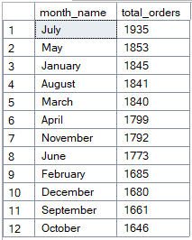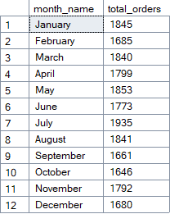

**------------------------------------------------------------**

**## 🍕 SALES PERCENTAGE ANALYSIS**

**------------------------------------------------------------**

**# 🔸 % Sales by Pizza Category (Overall)**

**SELECT**

**pizza_category,**

**CAST(SUM(total_price) AS DECIMAL(10,2)) AS total_sales,**

**CAST(**

**SUM(total_price) * 100.0 / (SELECT SUM(total_price) FROM pizza_sales)**

**AS DECIMAL(10,2)) AS sales_percentage**

**FROM pizza_sales**

**GROUP BY pizza_category;**

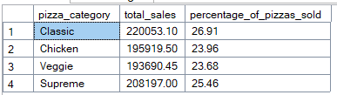

**# 🔸 % Sales by Pizza Category (For a Particular Month - Example: January)**

**SELECT**

**pizza_category,**

**CAST(SUM(total_price) AS DECIMAL(10,2)) AS total_sales,**

**CAST(**

**SUM(total_price) * 100.0 /**

**(SELECT SUM(total_price) FROM pizza_sales WHERE MONTH(order_date) = 1)**

**AS DECIMAL(10,2)) AS sales_percentage**

**FROM pizza_sales**

**WHERE MONTH(order_date) = 1**

**GROUP BY pizza_category;**

**------------------------------------------------------------**

**## 🧱 PIZZA SIZE SALES ANALYSIS**

**------------------------------------------------------------**

**# 🍕 Sales % by Pizza Size**

**SELECT**

**pizza_size,**

**SUM(quantity) AS total_pizzas_sold,**

**CAST(**

**SUM(quantity) * 100.0 / (SELECT SUM(quantity) FROM pizza_sales)**

**AS DECIMAL(10,2)) AS sales_percentage**

**FROM pizza_sales**

**GROUP BY pizza_size**

**ORDER BY total_pizzas_sold DESC;**

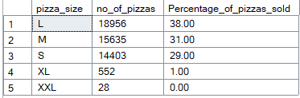

**------------------------------------------------------------**

**## 🏆 BEST & WORST SELLING PIZZAS**

**------------------------------------------------------------**

**# ⭐ Top 5 Best-Selling Pizzas (by Revenue, Orders, Quantity)**

**SELECT TOP 5**

**pizza_name_id,**

**SUM(quantity) AS total_pizzas_sold,**

**COUNT(DISTINCT order_id) AS total_orders,**

**SUM(total_price) AS total_revenue**

**FROM pizza_sales**

**GROUP BY pizza_name_id**

**ORDER BY total_revenue DESC;**

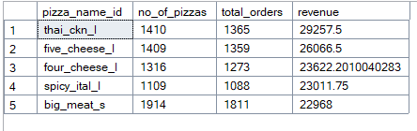

**# ❌ Bottom 5 Worst-Selling Pizzas (by Revenue, Orders, Quantity)**

**SELECT TOP 5**

**pizza_name_id,**

**SUM(quantity) AS total_pizzas_sold,**

**COUNT(DISTINCT order_id) AS total_orders,**

**CAST(SUM(total_price) AS DECIMAL(10,2)) AS total_revenue**

**FROM pizza_sales**

**GROUP BY pizza_name_id**

**ORDER BY total_revenue ASC;**

